Combustion synthesis and characterization studies of Co₃O₄ nanoparticles

G. Padmapriya

Department of Chemistry, Bharath Institute of Higher Education and Research,
Bharath University, Chennai – 600 073, Tamil Nadu, India

Abstract
Spinel Co₃O₄ nanoparticles were synthesized by microwave heating method. The synthesized Co₃O₄ nanoparticles were successfully characterized by powder XRD pattern, FT-IR spectra, EDX analysis, HR-SEM analysis, and VSM techniques. XRD pattern, FT-IR and EDX results established the development of Co₃O₄ nanocrystals. The formation of spherical shaped nanoparticles was confirmed by HR-SEM technique. VSM measurements revealed that Co₃O₄ have superparamagnetic behavior.
Keywords: Spinel Co₃O₄; Nanoparticles; Magnetic properties;

1. Introduction
Recently, nanostructured materials are attractive in materials science and nanotechnology, for the reason that of their novel physical, chemical and catalytic activities than that of their same bulkiness materials [1-5]. Among the various materials, Co₃O₄, has gained much attention in interdisciplinary areas due to their high mechanical strength, and chemical stability [6-8]. Various synthesis routes have been used to prepare the spinel type nanomaterials [8-10]. Recently, a facile microwave combustion method (MCM) has been used. In this route, the nanomaterials are synthesized at lower temperatures and also enough low cost with good controlled size of the products [10-12].
The present work focused on the synthesis of spinel Co₃O₄ nanoparticles by using green method. Moreover, spinel Co₃O₄ nanomaterials are non-toxic, inexpensive, comparatively higher surface area and the properties formulate them proper for use as inexpensively and environmentally feasible solid heterogeneous nano-catalysts. The prepared sample was characterized by XRD, FT-IR, HR-SEM, EDX and VSM techniques and the achieved results are discussed.

2. Experimental
2.1. Materials and methods
Nitrates of cobalt as the raw materials were used by this method and were dissolved in under stirring for 1 h and then located in a domestic microwave oven for 10 min. After completion of the reaction, the solid powder was then washed with wated ethanol and dried at 70 ºC for 1h. The obtained powders were labeled as Co₃O₄.

2.2. Characterization
The structural characterization of Co₃O₄ nano-crystals were carry out using a Rigaku Ultima XRD (λ = 1.5418 Å). The functional groups were analyzed by Perkin Elmer FT-IR spectra. The morphology of the samples was achieved at desired magnification with a Joel JSM 6360 HR-SEM analysis. Magnetic properties were carried out using a PMC MicroMag 3900 model VSM.

3. Results and discussion
3.1. Powder XRD analysis
The crystal structure, crystallite size and phase formation of the powders were established by analyze the powder XRD pattern. Fig. 1 shows the XRD pattern of Co₃O₄ nanoparticle. The peaks of 31.13, 36.84, 38.64, 44.53, 49.14, 55.73, 59.43, 65.53, 74.25 and 77.52° can be absolutely indexed as fcc spinel Co₃O₄.
The crystallite size was calculated using Scherrer’s Eq. (1),
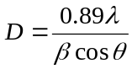 ---- (1)
where ‘D’ the crystallite size, ‘λ’ is the X-ray wavelength, ‘β’ is the full width at half maximum (FWHM) and ‘θ’ is the Bragg diffraction angle. The calculated average crystallite size of the sample is 25.32 nm.

3.2 FT-IR analysis
Fig. 2 shows the FT-IR spectra of Co₃O₄ nanoparticle. A wide-ranging band appeared in the expanse 3220-3440 cm⁻¹ showed the vibrations of water H₂O molecules. A band at around 1630 cm⁻¹ assigned H-O-H vibration. The absorption band at 2357 cm⁻¹ is due to the CO₂ molecule stretching vibration. The M-O stretching bands are observed in the range 550-850 cm⁻¹, connected to the Co-O bonds [14, 15].

3.3 SEM studies
The morphology of Co₃O₄ sample was confirmed by HR-SEM analysis. Fig. 3 shows HR-SEM image of Co₃O₄. HR-SEM image clearly shows the agglomerated particle-like nano-crystals with irregular grain size smaller than 50 nm. From the results, it is assumed that, during the microwave heating process, the microwaves are involved for nucleation and formed the final products with narrow size range of particles within few minutes.

3.4 EDX studies
Elemental and phase purity was confirmed by EDX spectral analysis. Fig. 4 shows the EDX spectra of Co₃O₄. EDX results showed that the peaks of Co, O elements and there is no other secondary peak, which established the pure product formation.

3.9 VSM measurements
The magnetic activities of Co₃O₄ nanoparticle was analyzed through external field between ±10 kOe by VSM at room temperature. Magnetization (M) versus applied field (H) curve is shown in Fig. 5. From the M-H curve, we can infer that a soft magnetic nature of Co₃O₄ and also indicate superparamagnetism at ±15 kOe. The obtained results show that the value of M_{s} is 1.45× 10⁻⁴ emu/g. However, it is noted that lower M_{s}, H_{c} and M_{r} values confirmed the Co₃O₄ have soft nature of superparamagnetism [16-22].

4. Conclusions
Co₃O₄ nano-catalysts were prepared by a easy microwave heating route. Powder XRD and EDX results specified that the prepared sample has a spinel without any secondary phase impurities. The manifestation of wide-ranging band between 550 and 850 cm⁻¹ in FT-IR spectra exposed the arrangement of bonds appeared in the samplel. HR-SEM image showed the construction of well residential particle morphology with nano-sized grains. VSM studies revealed that Co₃O₄ superparamagnetism.

References
- A. Manikandan, R. Sridhar, S. Arul Antony, S. Ramakrishna, Journal of Molecular Structure, 1076 (2014) 188-200.
- A. Manikandan, M. Durka, K. Seevakan, S. Arul Antony, Journal of Superconductivity and Novel Magnetism, 28 (2015) 1405-1416.
- A. Manikandan, M. Durka, S. Arul Antony, Journal of Superconductivity and Novel Magnetism, 28 (2015) 209–218.
- A. Manikandan, M. Durka, S. Arul Antony, Journal of Inorganic and Organometallic Polymers and Materials, 25 (2015) 1019–1031.
- A. Manikandan, M. Durka, S. Arul Antony, Journal of Superconductivity and Novel Magnetism, 27 (2014) 2841–2857.
- A. Manikandan, S. Arul Antony, R. Sridhar, M. Bououdina, Journal of Nanoscience and Nanotechnology, 15 (2015) 4948-4960.
- A. Manikandan, M. Durka, S. Arul Antony, Advanced Science, Engineering and Medicine, 7 (2015) 33-46.
- A. Manikandan, E. Hema, M. Durka, K. Seevakan, T. Alagesan, S. Arul Antony, Journal of Superconductivity and Novel Magnetism, 28 (2015) 1783-1795.
- A. Manikandan, M. Durka, S. Arul Antony, Journal of Superconductivity and Novel Magnetism, 28 (2015) 2047–2058.
- M. F. Valan, A. Manikandan, S. Arul Antony, Journal of Nanoscience and Nanotechnology, 15 (2015) 4543-4551.
- E. Hema, A. Manikandan, S. Suganya, M. Durka, S. Arul Antony, B. R. Venkatraman,
Journal of Superconductivity and Novel Magnetism, 28, 8 (2015) 2539-2552.
- S. Jayasree, A. Manikandan, A. M. Uduman Mohideen, C. Barathiraja, E. Hema, S. Arul Antony, Advanced Science, Engineering and Medicine, 7, (2015) 672-682.
- A. Manikandan, M. Durka, M. Amuth Selvi, S. Arul Antony, Journal of Nanoscience and Nanotechnology, 16 (2016) 357-373.
- A. Mary Jacintha, A. Manikandan, K. Chinnaraj, S. Arul Antony, P. Neeraja, Journal of Nanoscience and Nanotechnology, 15 (2015) 9732-9740.
- A. Manikandan, M. Durka, M. Autha Selvi, S. Arul Antony, Journal of Nanoscience and Nanotechnology, 16 (2016) 448-456.
- A. Manikandan, A. Saravanan, S. Arul Antony, M. Bououdina, Journal of Nanoscience and Nanotechnology, 15 (2015) 4358-4366.
- A. Manikandan, S. Arul Antony, Journal of Superconductivity and Novel Magnetism, 27 (2014) 2725-2733.
- A. Manikandan, M. Durka, S. Arul Antony, Journal of Inorganic and Organometallic Polymers and Materials, 25 (2015) 804–815.
- K. Chinnaraj, A. Manikandan, P. Ramu, S. Arul Antony, P. Neeraja, Journal of Superconductivity and Novel Magnetism, 28 (2015) 179-190.
- M. F. Valan, A. Manikandan, S. Arul Antony, Journal of Nanoscience and Nanotechnology, 15 (2015) 4580-4586.
- E. Hema, A. Manikandan, S. Suganya, M. Durka, S. Arul Antony, B. R. Venkatraman,
Journal of Superconductivity and Novel Magnetism, 28, 8 (2015) 2539-2552.
- D. K. Manimegalai, A. Manikandan, S. Moortheswaran, S. Arul Antony, Journal of Superconductivity and Novel Magnetism, 28, 9, (2015) 2755-2766

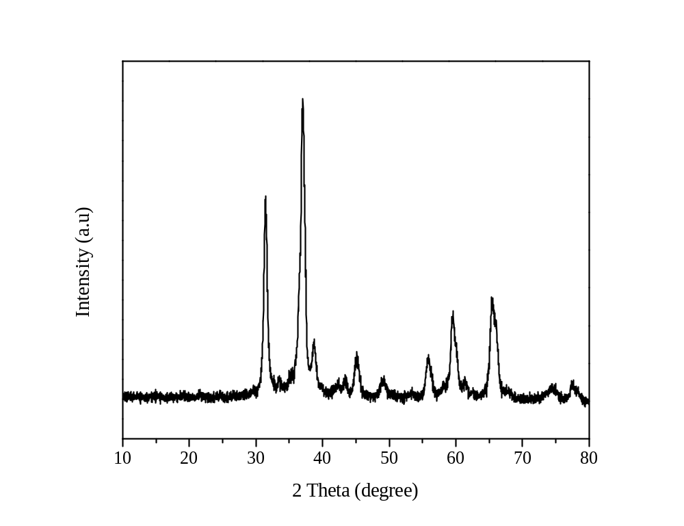

Figure 1. Powder XRD pattern of Co₃O₄ sample.

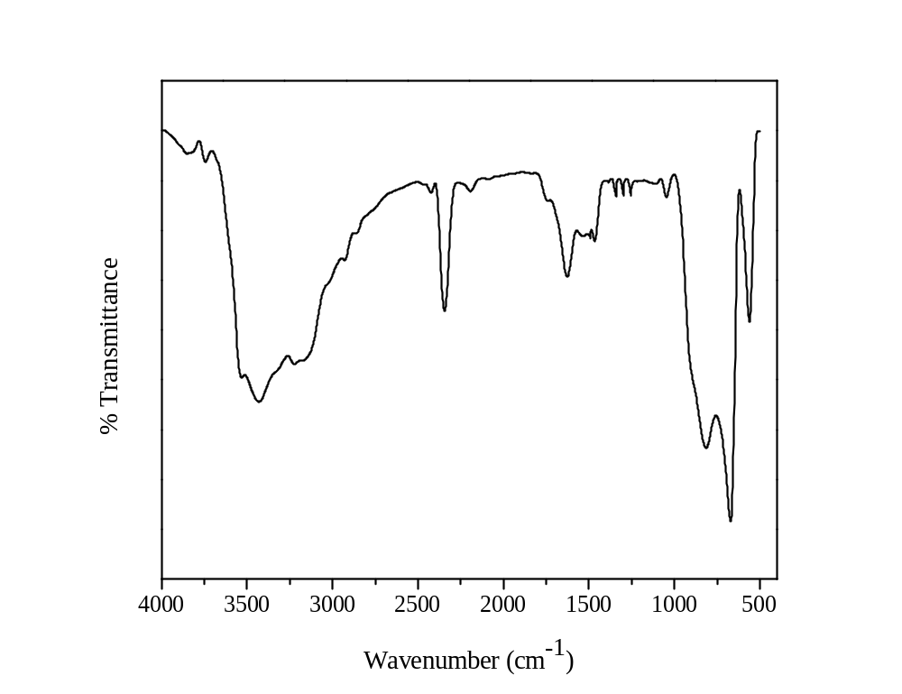

Figure 2. FT-IR spectra of Co₃O₄ sample.

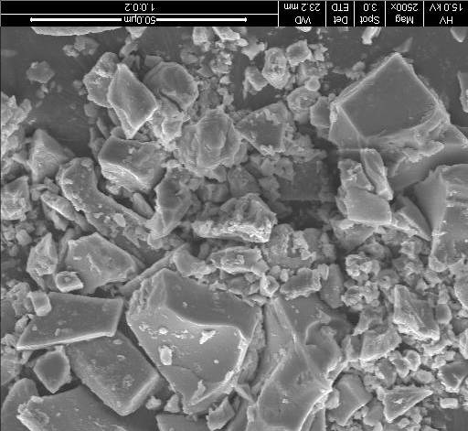
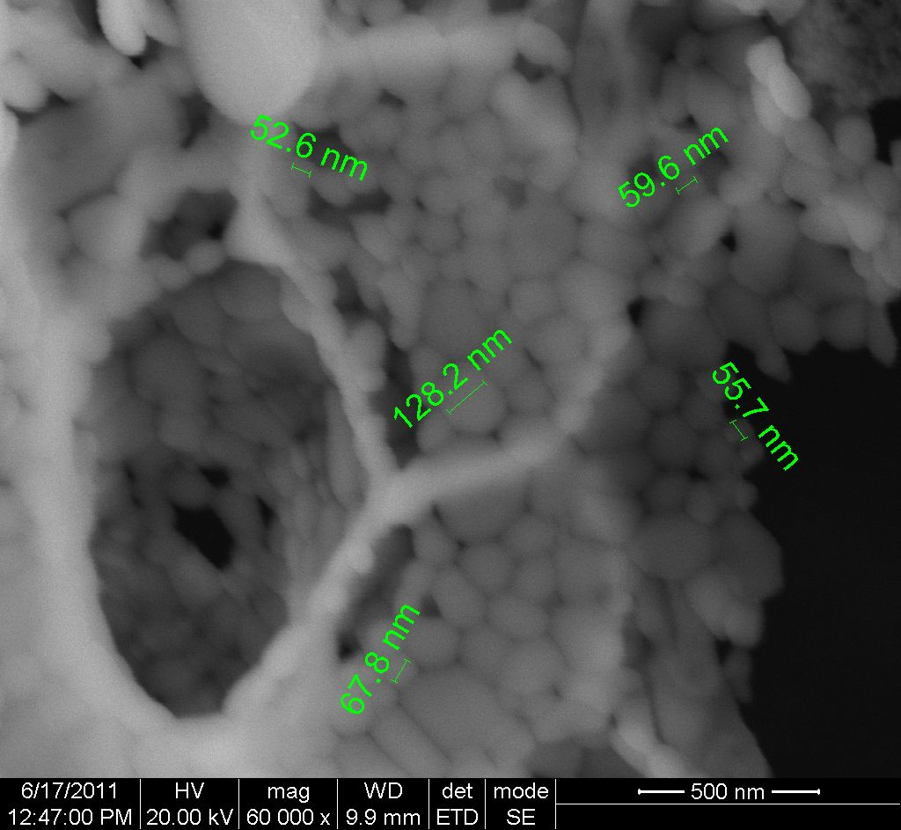

Figure 3. HR-SEM image of Co₃O₄ sample.

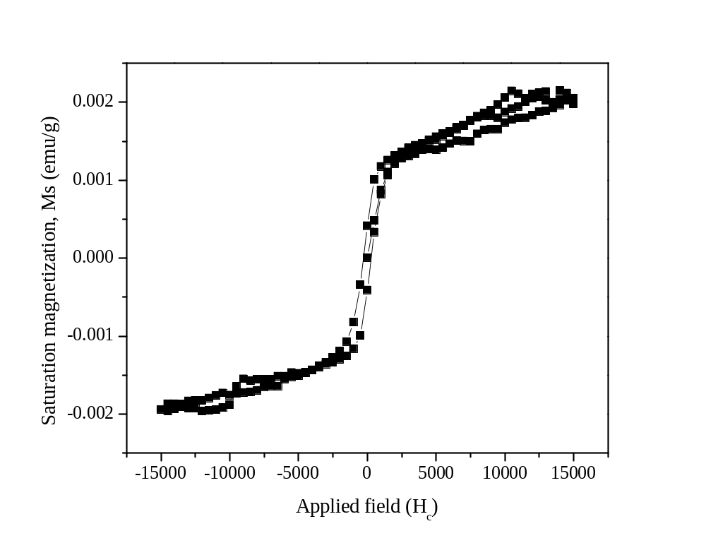

Figure 4. Magnetic hysteresis (M-H) loop of Co₃O₄ sample.

